CS 255 System Design Document Template

UML Diagrams

UML Use Case Diagram

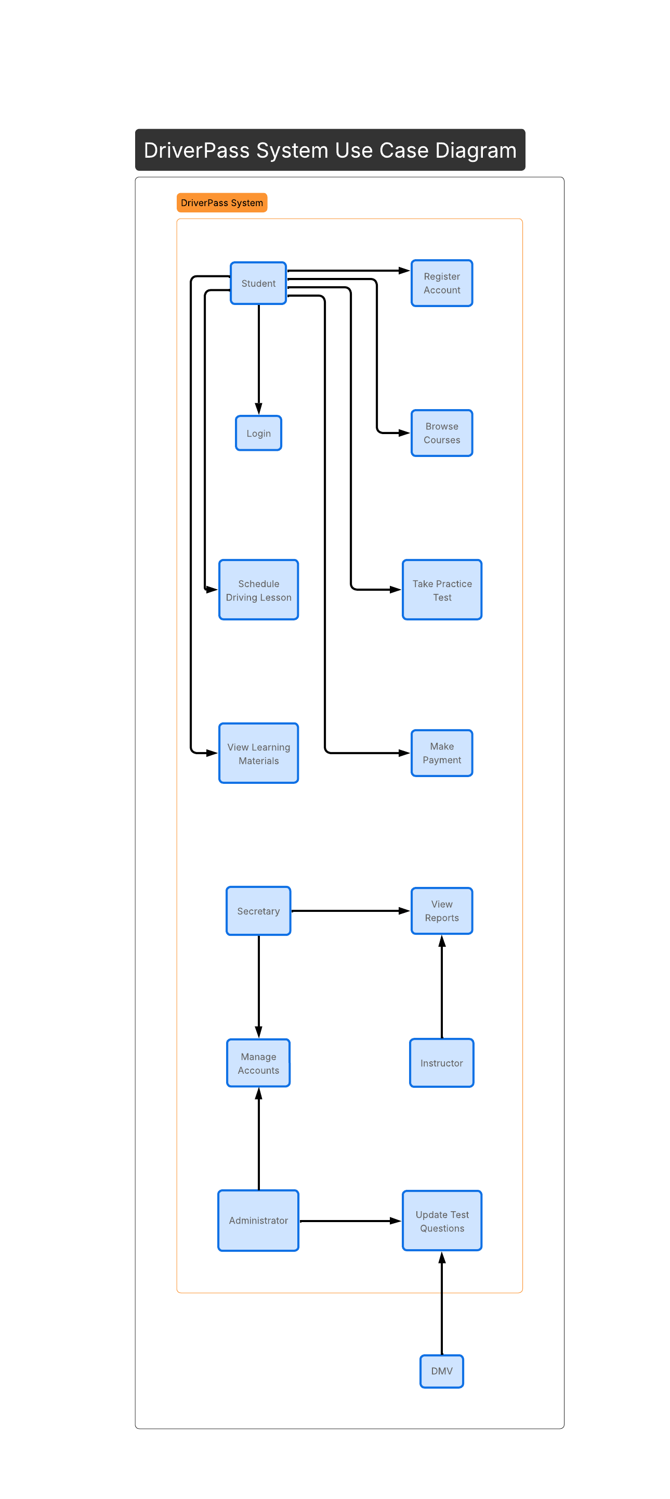

[The use case diagram illustrates how different users interact with the DriverPass system. Students can register accounts, log in, browse courses, schedule driving lessons, take practice tests, view learning materials, and make payments. Secretaries can manage accounts and view reports. Instructors can view reports related to their lessons. Administrators manage accounts and update test questions. The system also connects with the DMV to receive updated testing information. This diagram ensures that all user interactions required by DriverPass are supported.]

UML Activity Diagrams

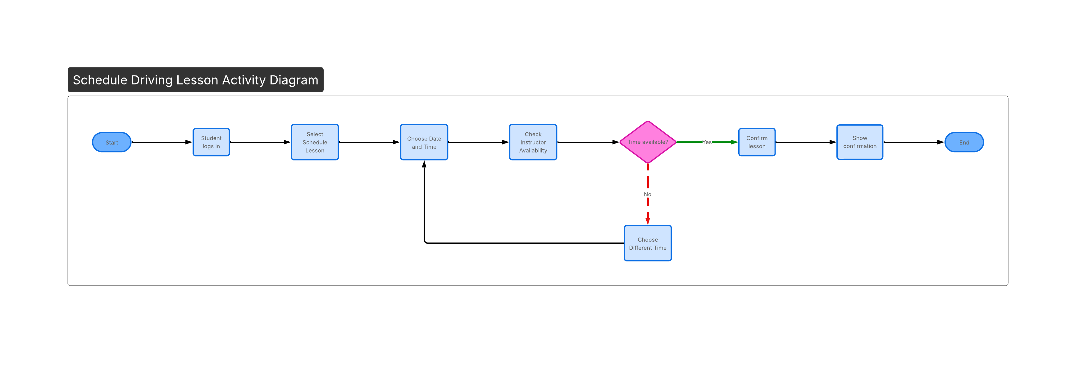
[This activity diagram shows the step-by-step process for scheduling a driving lesson. The student logs in, selects a lesson time, and the system checks instructor availability. If the time is available, the lesson is confirmed and a confirmation message is displayed. If the time is not available, the student selects a different time. This process ensures efficient scheduling and accurate booking.]
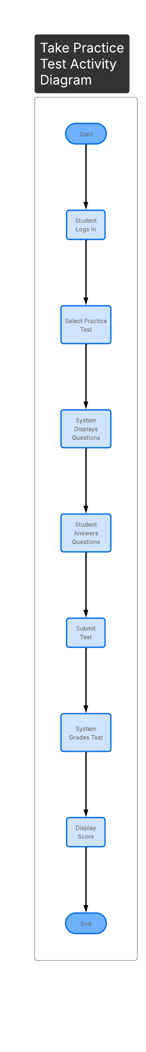

[This activity diagram represents the process of taking an online practice test. The student logs in, selects the practice test option, answers the questions, and submits the test. The system grades the test automatically and displays the score. This functionality allows students to prepare for the DMV test in a convenient and structured way.]

UML Sequence Diagram

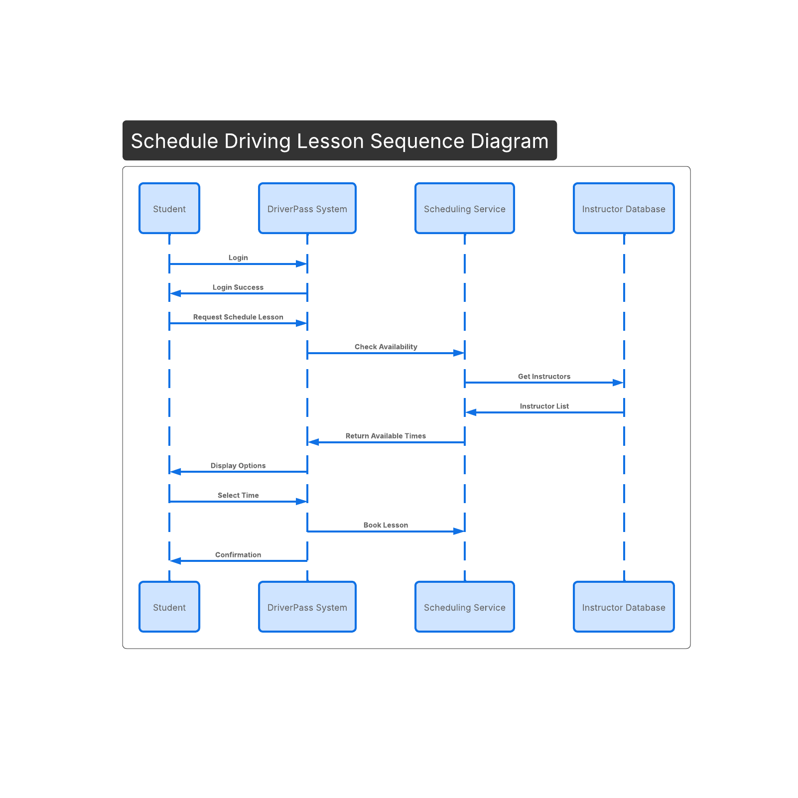

[The sequence diagram demonstrates how different components of the system communicate during the lesson scheduling process. The student sends a request to schedule a lesson. The system checks instructor availability through the scheduling service and instructor database. Once availability is confirmed, the system presents options to the student and confirms the selected lesson time. This diagram highlights how data flows between system components.]

UML Class Diagram
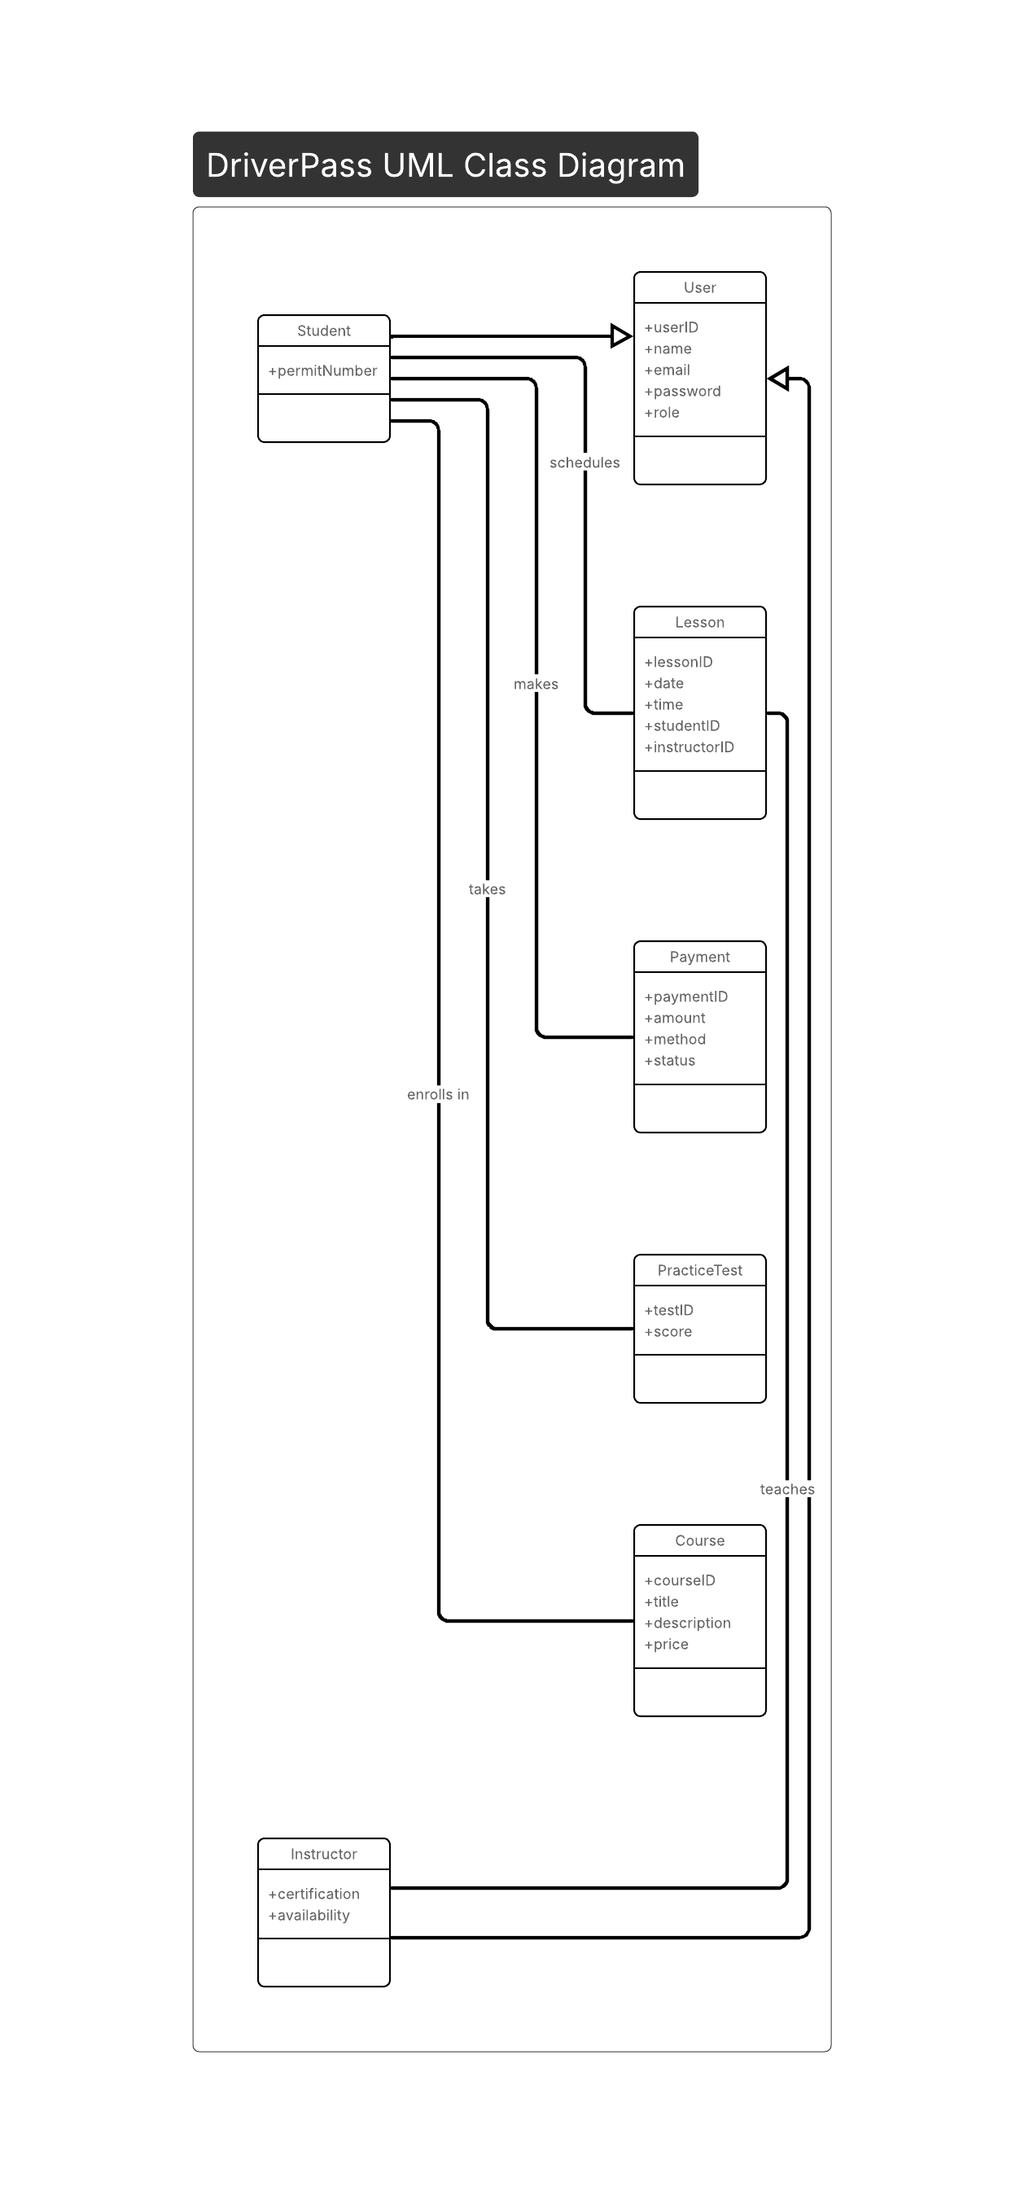
[The class diagram outlines the main structural components of the DriverPass system. The User class serves as a base class for Student and Instructor through inheritance. Students can schedule lessons, make payments, enroll in courses, and take practice tests. Instructors teach lessons. Other core classes include Lesson, Payment, PracticeTest, and Course. Each class contains relevant attributes that support the system’s functionality and ensure organized data management.]

Technical Requirements
The DriverPass system requires specific hardware, software, tools, and infrastructure to function effectively.

Hardware Requirements
- Cloud-based server to host the application
- Desktop computers for administrative staff
- Laptops, tablets, or smartphones for students
- Reliable high-speed internet connection

Software Requirements
- Web-based application compatible with modern browsers (Chrome, Edge, Safari)
- Secure database management system
- Payment processing integration
- Operating systems compatible with Windows and macOS

Development Tools
- Lucidchart for UML modeling
- Integrated Development Environment (IDE) for application development
- Version control system such as GitHub

Infrastructure Requirements
- Secure cloud hosting environment
- Data encryption for sensitive user information
- Role-based access control
- Firewall protection
- Regular system backups and recovery procedures
These technical requirements ensure the DriverPass system is secure, reliable, scalable, and accessible to users.

